Assignment 1 : Java

Task 1 :

Write a program that declares variables for a student’s name, roll number, and marks in three
subjects. Assign values and print them. Ensure all variable names follow Java identifier rules.

Solution -

public class StudentInfo {
public static void main(String[] args)
{
String studentName = "Vaibhav";
int rollNumber = 1101;
double Java_Practical = 78.5;
double Java_lab = 93.0;
double Machine_Learning = 78.0;

System.out.println("Student Name : " + studentName);
System.out.println("Roll Number : " + rollNumber);
System.out.println("Java Practical Marks : " + Java_Practical);
System.out.println("Java lab Marks : " + Java_lab);
System.out.println("Machine Learning Marks : " + Machine_Learning);
}
}

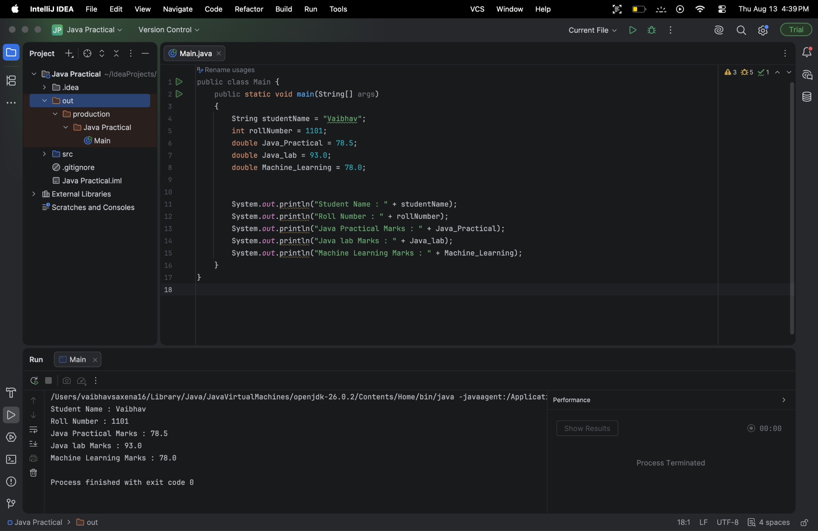

Task 2 :

Write a Java program that:
• Stores an integer value for temperature in Celsius.
• Converts it to Fahrenheit using the formula F = (C × 9/5) + 32.
• Displays both Celsius and Fahrenheit values.

Solution -

public class TemperatureConverter
{
public static void main(String[] args)
{
int celsius = 45;

// Using 9.0 / 5 to prevent integer truncation during division
double fahrenheit = (celsius * 9.0 / 5) + 32;
//declared a function and defined it

System.out.println("Celsius Temperature : " + celsius + "°C");
System.out.println("Fahrenheit Temperature : " + fahrenheit + "°F");
}
}
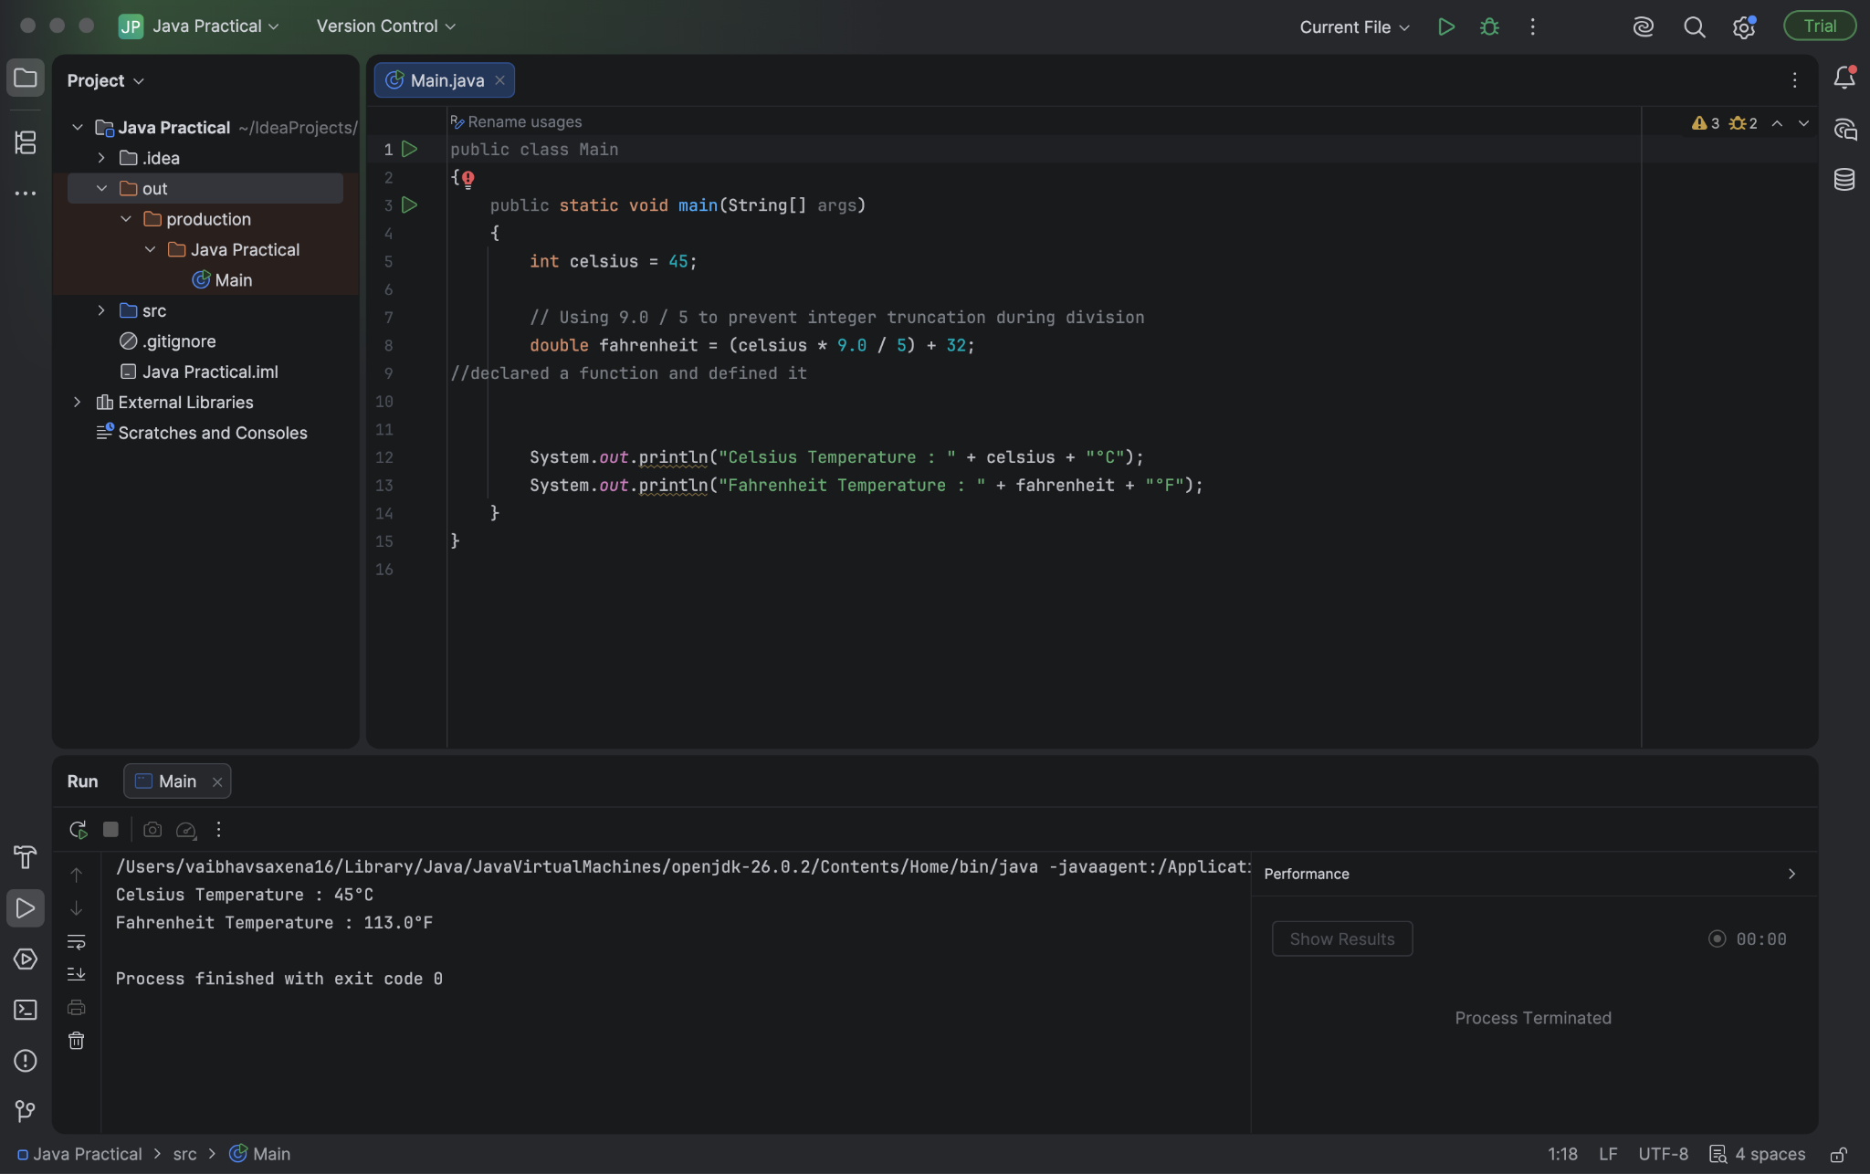

Task 3 :
Accept two integers from the user and perform addition, subtraction, multiplication, division, and
modulus. Display results for each operation.

Solution -

import java.util.Scanner;
public class ArithmeticOperations {
public static void main(String[] args) {
Scanner scanner = new Scanner(System.in);

System.out.print("Enter first integer: ");
int num1 = scanner.nextInt();

System.out.print("Enter second integer: ");
int num2 = scanner.nextInt();

System.out.println("Addition (+): " + (num1 + num2));
System.out.println("Subtraction (-): " + (num1 - num2));
System.out.println("Multiplication (*): " + (num1 * num2));

if (num2 != 0) {
System.out.println("Division (/): " + ((double) num1 / num2));
System.out.println("Modulus (%): " + (num1 % num2));
} else {
System.out.println("Division & Modulus: Cannot divide by zero.");
}

scanner.close();
}
}
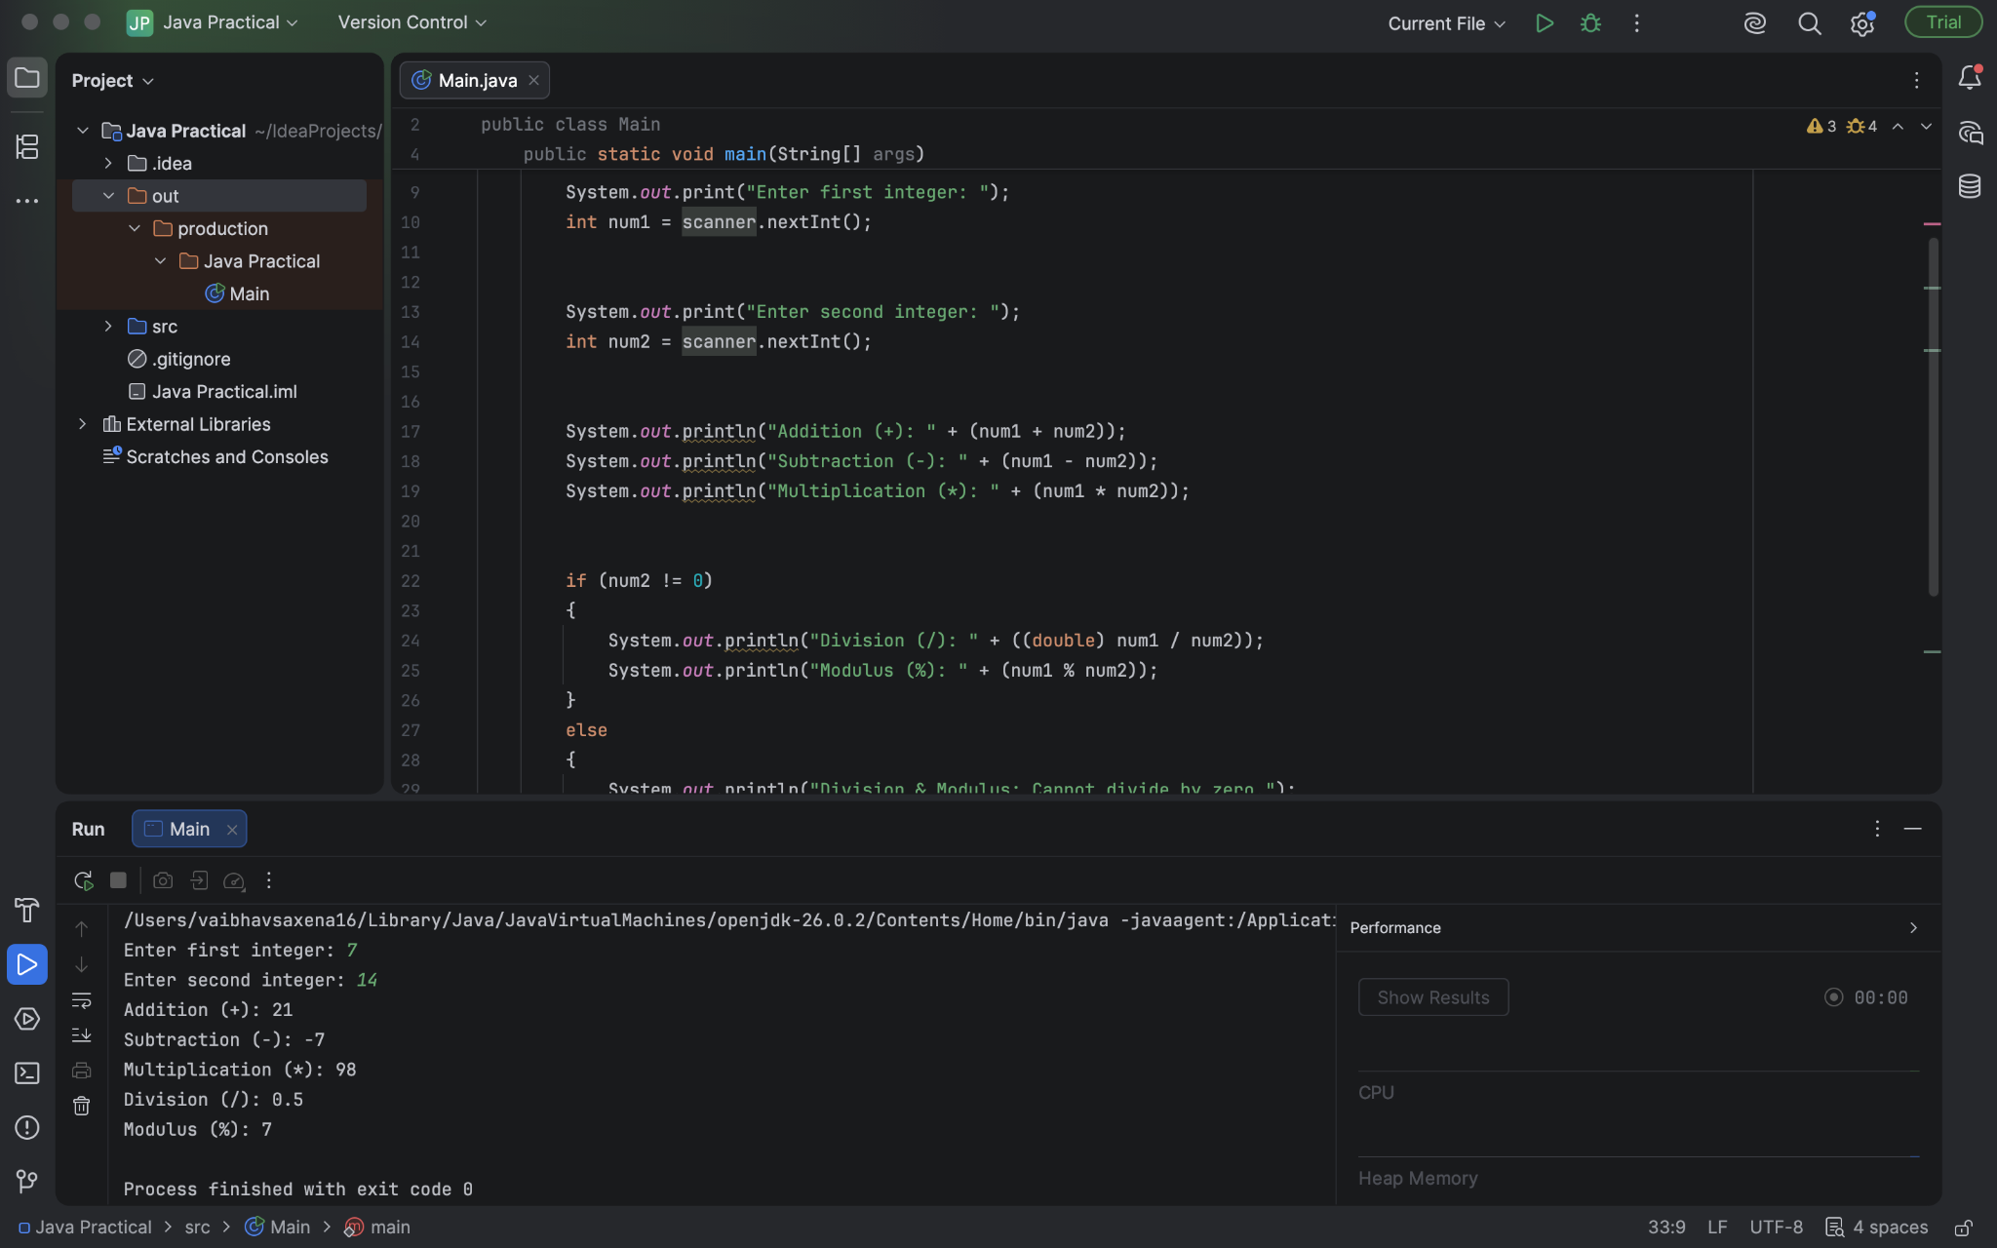

Task 4 :
Write a program to check if a person is eligible to vote.
• Input: age and citizenship status (true or false).
• Use logical operators (&&, ||) to decide eligibility.

Solution :

import java.util.Scanner;

public class VotingEligibility
{
public static void main(String[] args)
{
Scanner scanner = new Scanner(System.in);

System.out.print("Enter age: ");
int age = scanner.nextInt();

System.out.print("Are you a citizen? (true/false): ");
boolean isCitizen = scanner.nextBoolean();

// Both conditions must be true to vote
if (age >= 18 && isCitizen)
{
System.out.println("Result: Eligible to vote.");
} else
{
System.out.println("Result: NOT eligible to vote.");
}

scanner.close();
}
}
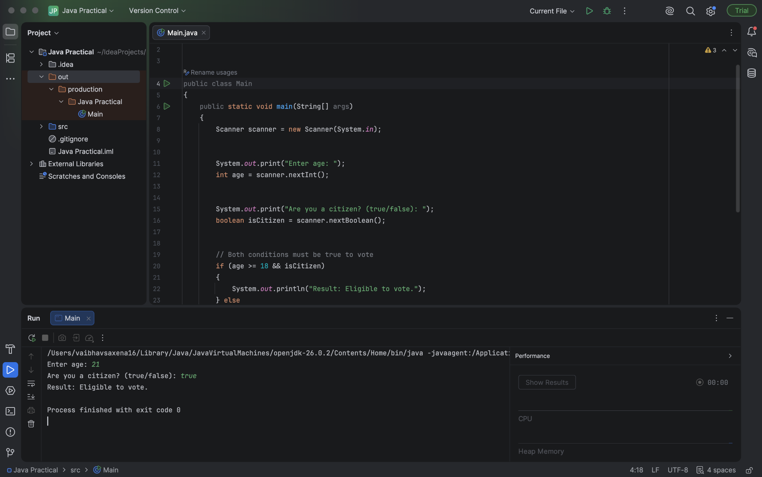

Task 5 :
Write a program that:• Takes two numbers and an operator symbol (+, -,*, /) from the user. Uses if-else statements to perform the appropriate operation.

Solution :
import java.util.Scanner;
public class SimpleCalculator {
public static void main(String[] args) {
Scanner scanner = new Scanner(System.in);

System.out.print("Enter first number: ");
double num1 = scanner.nextDouble();

System.out.print("Enter second number: ");
double num2 = scanner.nextDouble();

System.out.print("Enter operator (+, -, *, /): ");
char operator = scanner.next().charAt(0);

if (operator == '+') {
System.out.println("Result: " + (num1 + num2));
} else if (operator == '-') {
System.out.println("Result: " + (num1 - num2));
} else if (operator == '*') {
System.out.println("Result: " + (num1 * num2));
} else if (operator == '/') {
if (num2 != 0) {
System.out.println("Result: " + (num1 / num2));
} else {
System.out.println("Error: Division by zero is not allowed.");
}
} else {
System.out.println("Error: Invalid operator entered.");
}

scanner.close(); } }
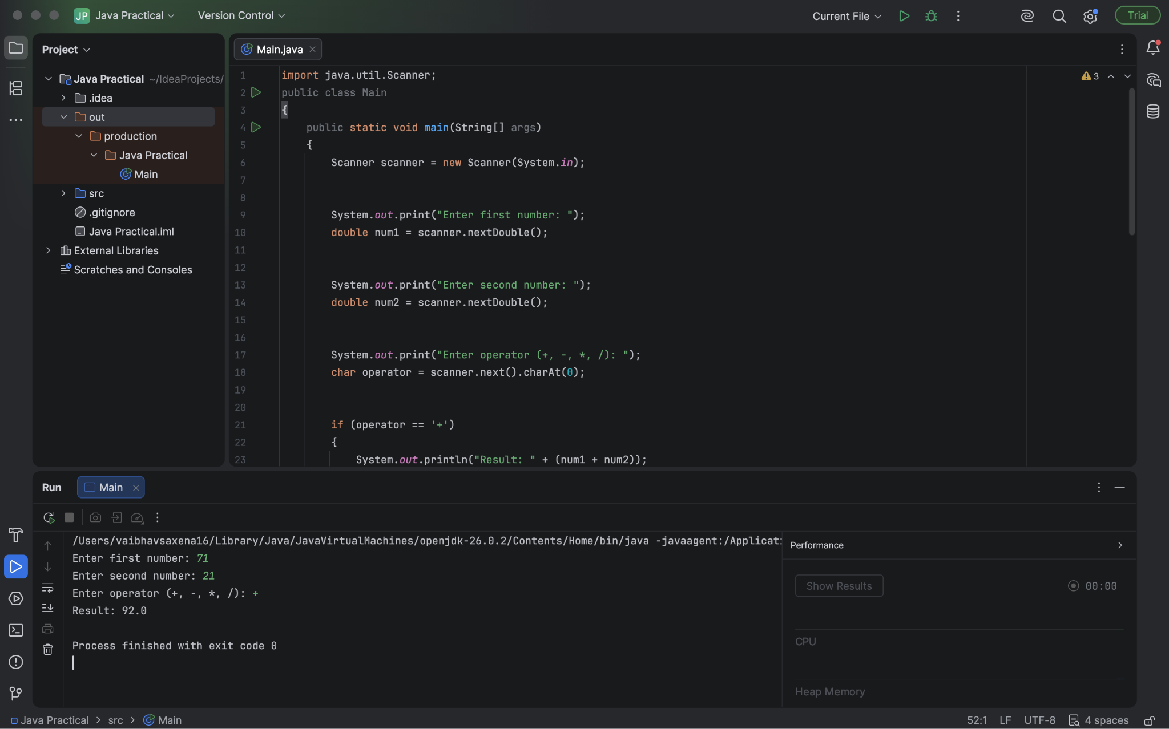

Task 6 :
Ask the user for a number and print its multiplication table from 1 to 10 using a for loop.

Solution :
import java.util.Scanner;

public class MultiplicationTable {
public static void main(String[] args) {
Scanner scanner = new Scanner(System.in);

System.out.print("Enter a number: ");
int number = scanner.nextInt();

System.out.println("--- Multiplication Table for " + number + " ---");
for (int i = 1; i <= 10; i++) {
System.out.println(number + " x " + i + " = " + (number * i));
}

scanner.close();
}
}

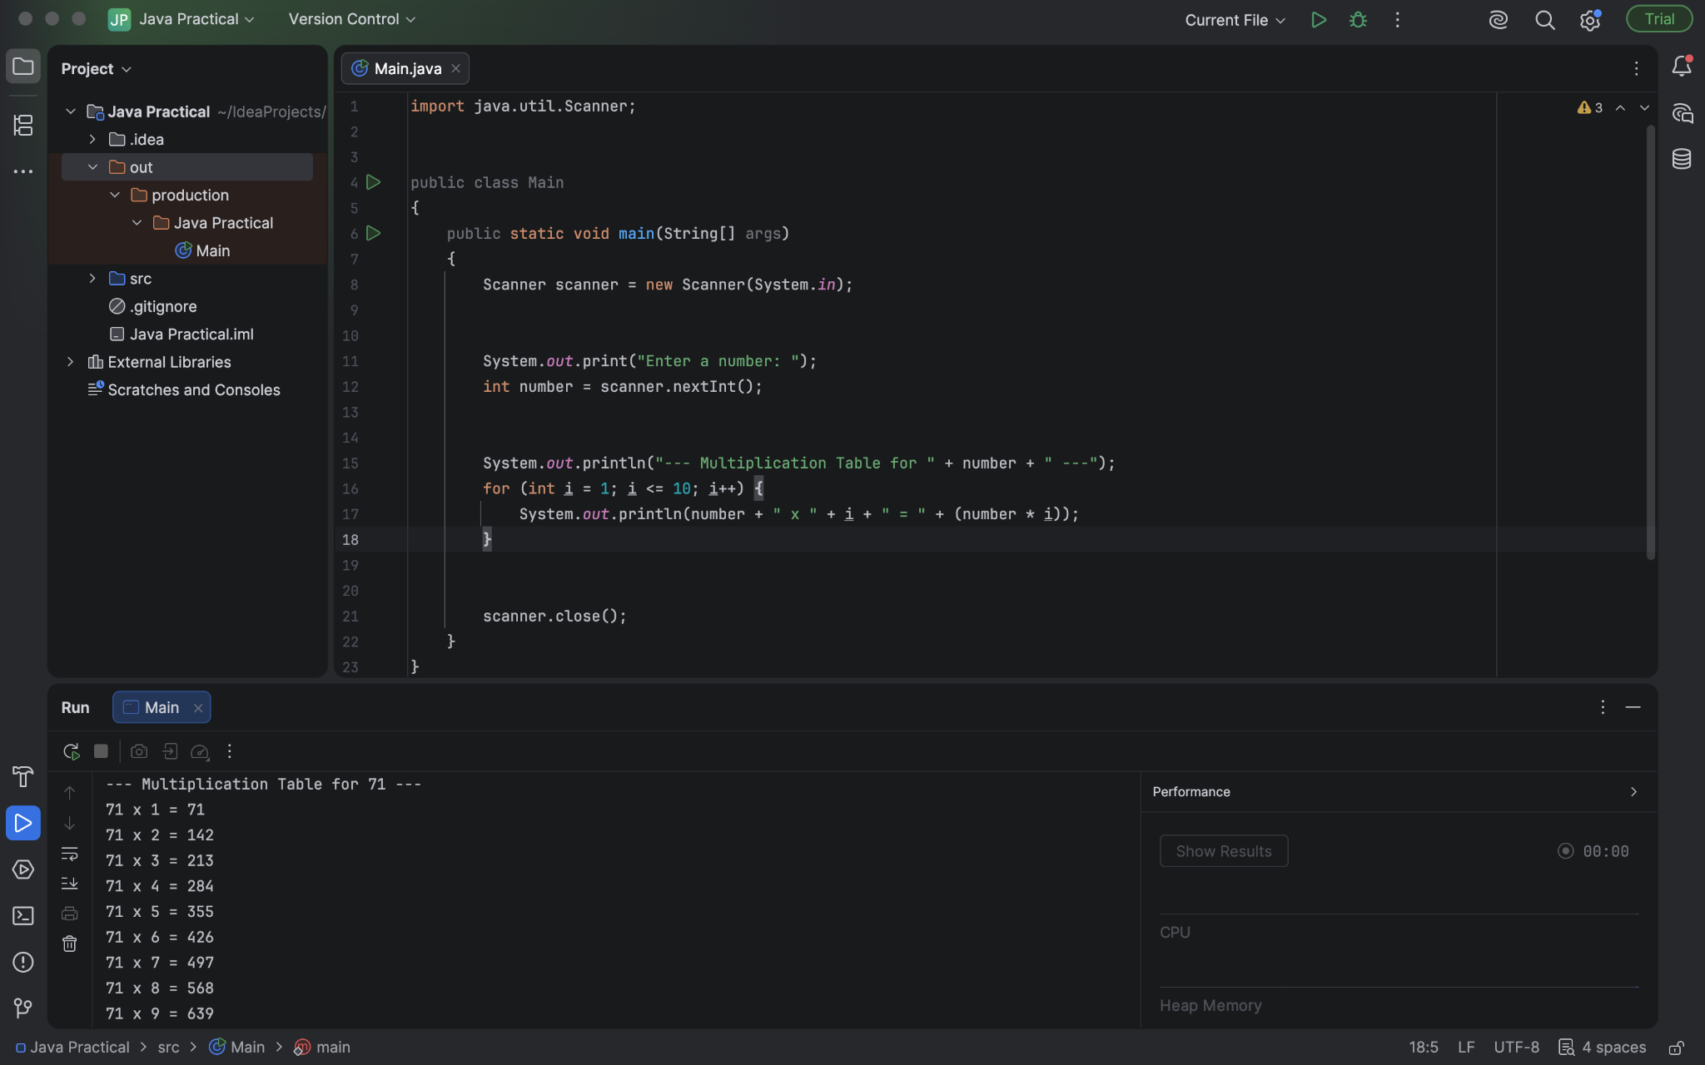

Task 7 :
Write a program that uses a while loop to find the sum of all even numbers between 1 and 50.

Solution :

public class SumOfEvenNumbers
{
public static void main(String[] args)
{
int sum = 0;
int number = 1;

while (number <= 50)
{
if (number % 2 == 0)
{
sum += number;
}
number++;
}

System.out.println("The sum of all even numbers between 1 and 50 is: " + sum);
}
}

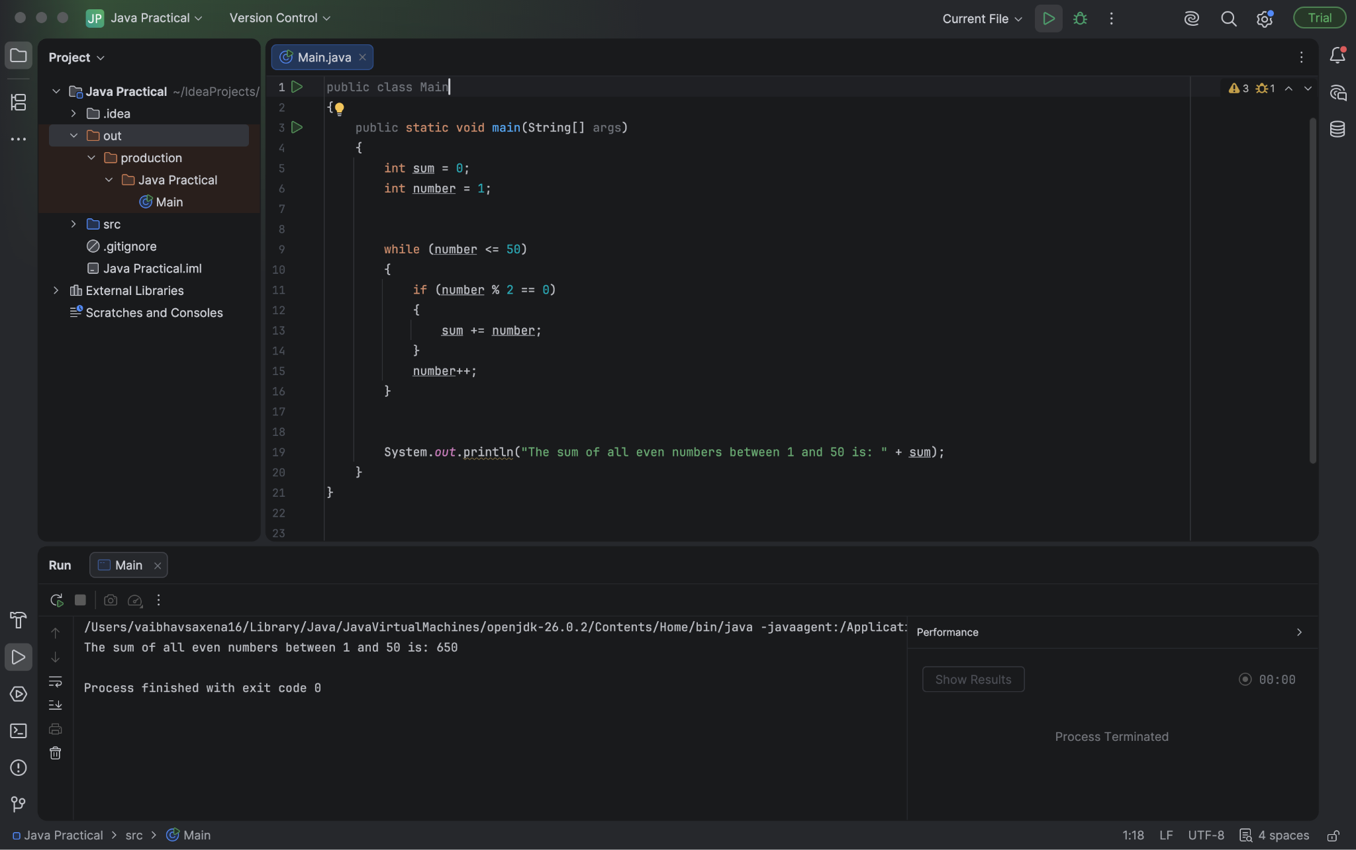

Task 8 :
Write a program that:
• Reads marks of 5 students into an integer array.
• Prints each student’s marks.

Solution :
import java.util.Scanner;

public class StudentMarksArray
{
public static void main(String[] args)
{
Scanner scanner = new Scanner(System.in);
int[] marks = new int[5];

System.out.println("Enter marks for 5 students:");
for (int i = 0; i < marks.length; i++)
{
System.out.print("Student " + (i + 1) + ": ");
marks[i] = scanner.nextInt();
}

System.out.println("\n--- Displaying Stored Marks ---");
for (int i = 0; i < marks.length; i++)
{
System.out.println("Student " + (i + 1) + " Marks: " + marks[i]);
}

scanner.close();
}
}
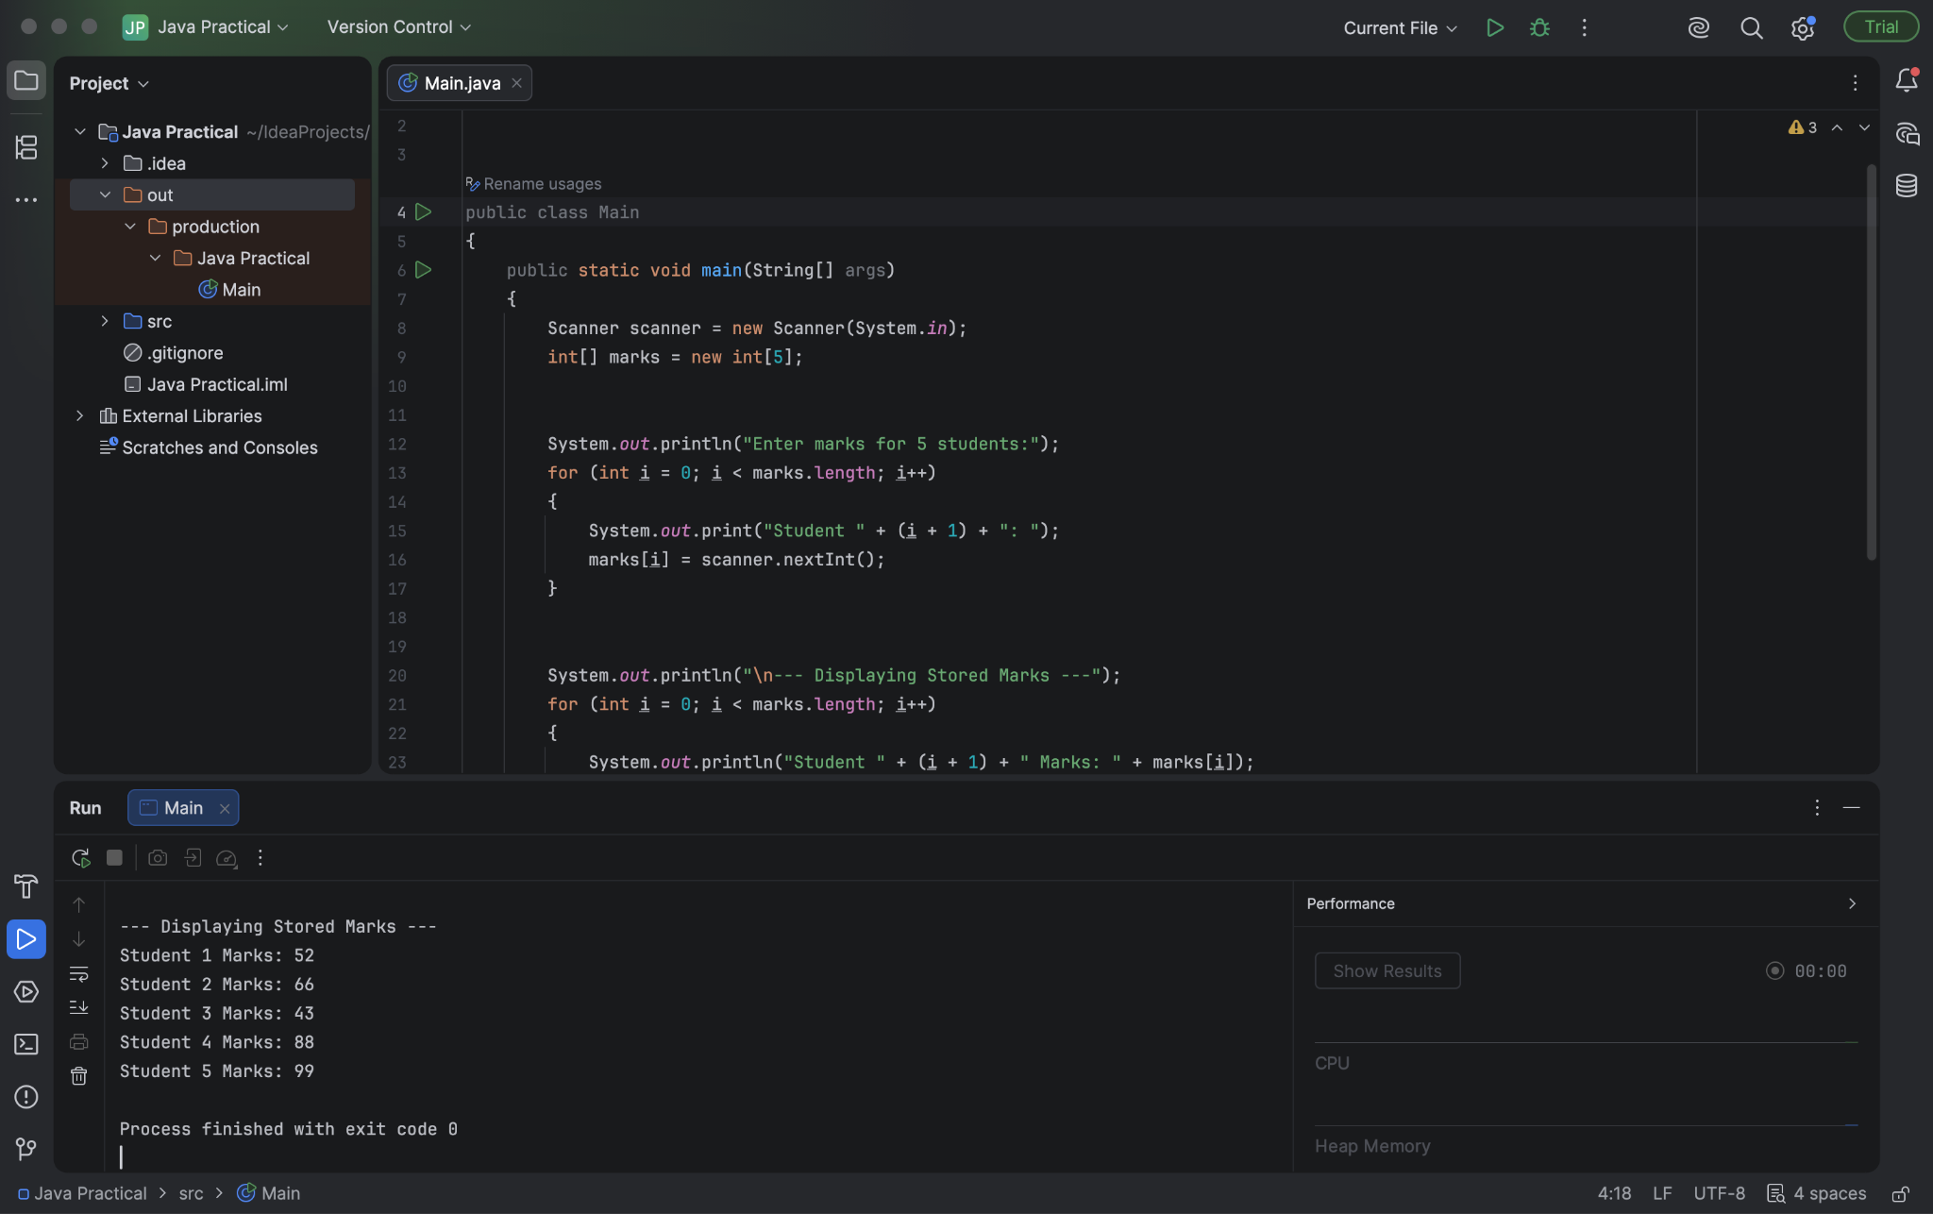

Task 9 :
Write a program to read 10 integers into an array and find the maximum value using a loop.

Solution :
import java.util.Scanner;

public class FindMaximumInArray
{
public static void main(String[] args)
{
Scanner scanner = new Scanner(System.in);
int[] numbers = new int[10];

System.out.println("Enter 10 integers:");
for (int i = 0; i < numbers.length; i++)
{
System.out.print("Element " + (i + 1) + ": ");
numbers[i] = scanner.nextInt();
}

int max = numbers[0];
for (int i = 1; i < numbers.length; i++)
{
if (numbers[i] > max)
{
max = numbers[i];
}
}

System.out.println("Maximum value in the array is: " + max);

scanner.close();
}
}
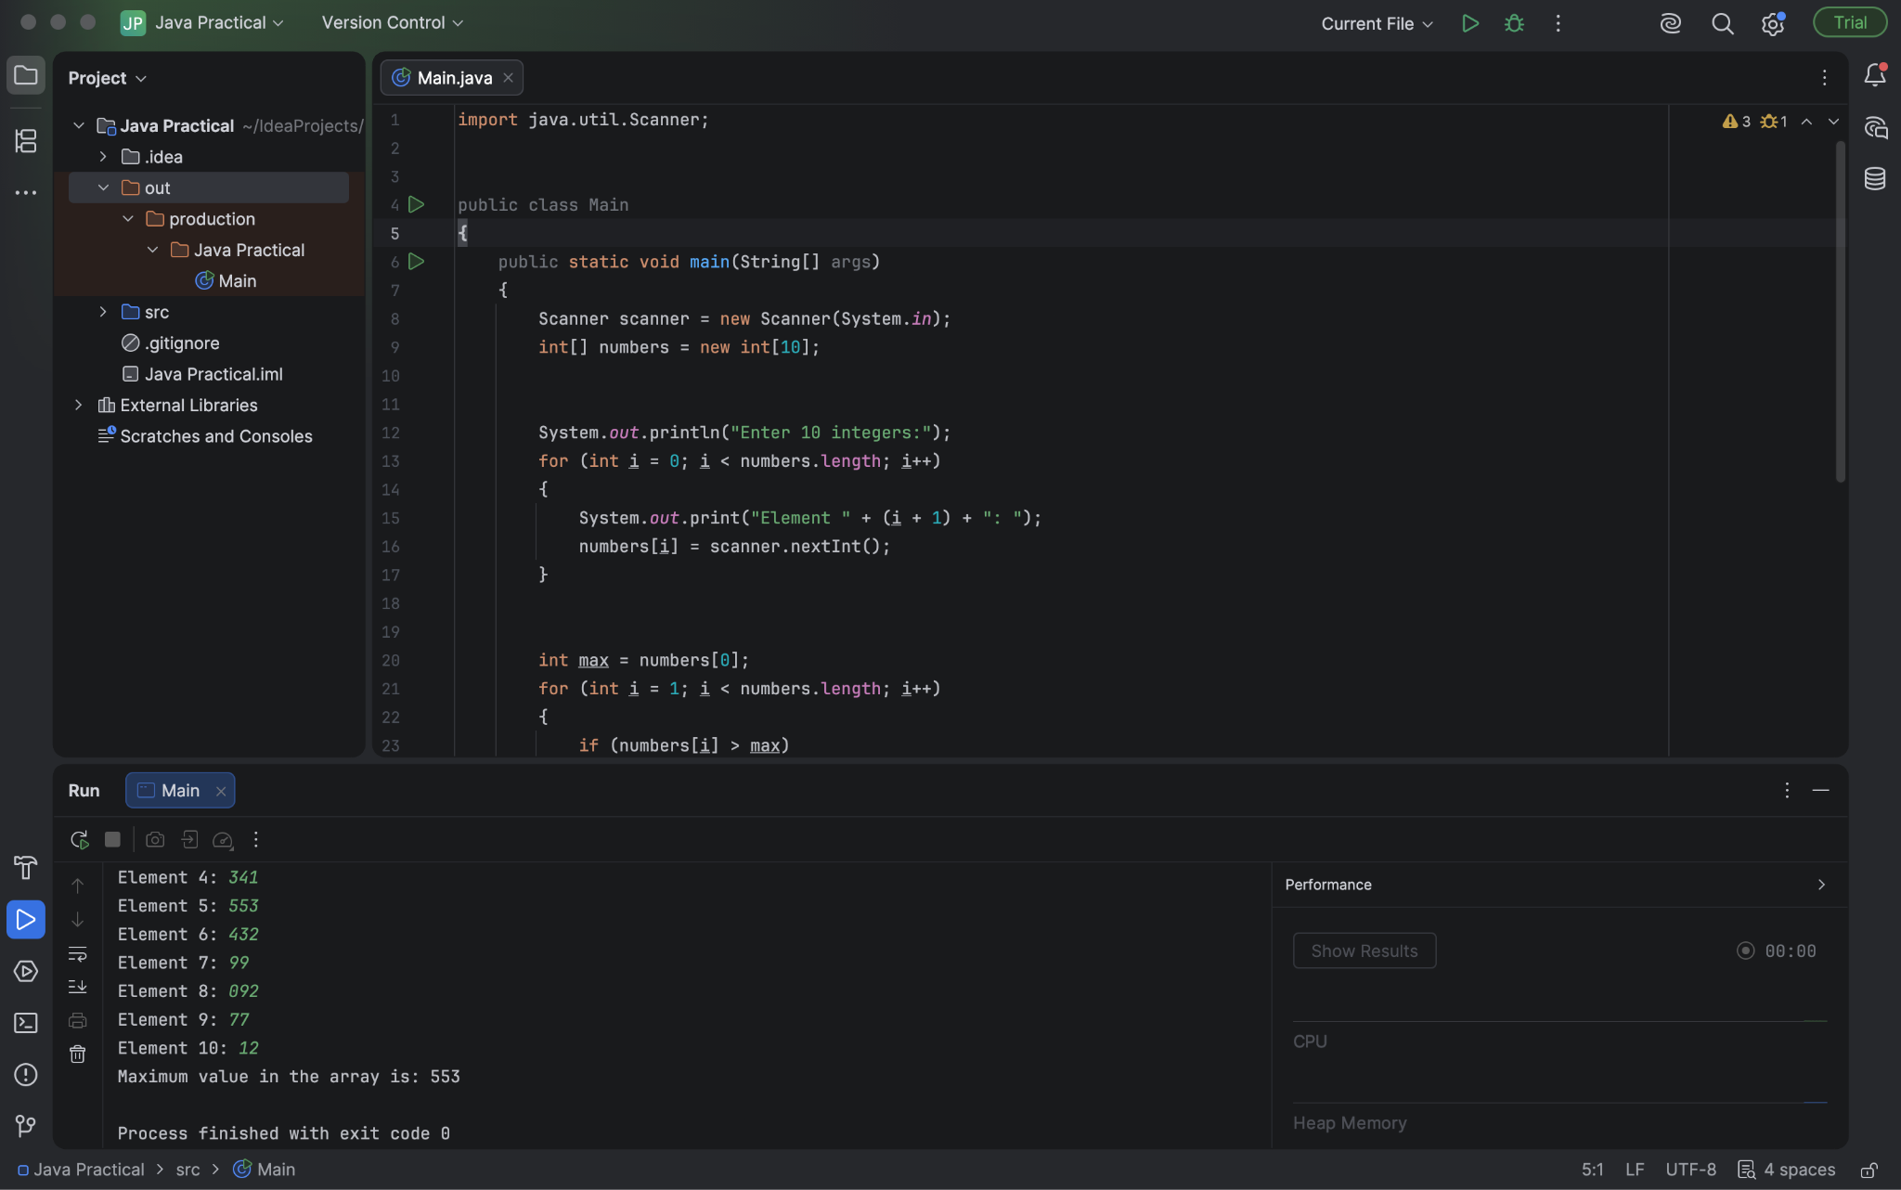

Task 10 :
Write a program that:
• Reads marks of 5 subjects into an array.
• Calculates the average marks.
• Uses if-else to assign grades:
o >= 90: A
o >= 75: Bo >= 50: C
o Else: Fail

Solution :

import java.util.Scanner;

public class StudentGradeSystem
{
public static void main(String[] args)
{
Scanner scanner = new Scanner(System.in);
double[] marks = new double[5];
double totalSum = 0;

System.out.println("Enter marks for 5 subjects:");
for (int i = 0; i < marks.length; i++)
{
System.out.print("Subject " + (i + 1) + ": ");
marks[i] = scanner.nextDouble();
totalSum += marks[i];
}

double average = totalSum / 5.0;
String grade;

if (average >= 90)
{
grade = "A";
} else if (average >= 75)
{
grade = "B";
} else if (average >= 50)
{
grade = "C";
} else {
grade = "Fail";
}

System.out.println("\nAverage Marks: " + average);
System.out.println("Grade: " + grade);

scanner.close();
}
}

